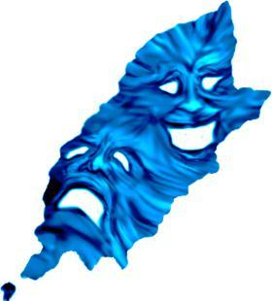
MADF One Act Play Festival
Wednesday 7th February to Saturday 10th February 2018
Entry Form

Please return the completed form, enclosing a copy of the script and the entry fee of £20.00 to the following address:

MADF One Act Play Festival 2018
Tedslair
21 Terence Avenue
Douglas
Isle of Man IM2 5BN

Payments can be made via cheque payable to MADF, or directly by bank transfer to MADF at:
Sort code: 55-91-00 Account: 57190313 quoting your team name and play title in the reference.

For any further information you may require please email: oneact@madf.im

Closing Date for Entries: Saturday 18th November 2017

Name of Theatre Group:
Category:
Youth (19 and under) or Adult

Contact Information
Name:
Address:
Including Post Code
Telephone: | Home |  | Mobile
Email address:

Play Details
Title:
Author:
Including any adaption, if applicable
Publisher:
Approximate Running Time:
In minutes
Cast List:
If required, attach a separate sheet
Synopsis of Play:
Maximum of 40 words
This will appear in the programme
Is Script Enclosed?

Method of Payment  Please circle as appropriate | Cash enclosed Cheque enclosed Bank Transfer

All-England Theatre Festival (AETF)
The teams achieving the highest mark in both the Youth and Adult categories will be eligible to compete in the next round, the North-West AETF, in England.
Please indicate whether this group wishes to be considered for entry into the next round of the competition. | Yes/No

Declarations
I (print name)
- Confirm I have read the rules of the MADF One Act Play Festival, and they are accepted by me on behalf of this Theatre Group.
- Confirm that none of the actors in this production are professional actors.
Signed:

MADF is now on ……

​Web:​ www.madf.im
Twitter:​ ​@madf_iom
Facebook: ​MADF - Manx Amateur Drama Federation

If you would like to supply your theatre group’s Twitter, we will follow.
Twitter:

If you would like to supply a link to your theatre group’s website, we will add it to the MADF website links page.
Website:

Please note that:
Any personal and/or group contact details submitted to MADF will be stored electronically in a secure cloud based file for committee access only and will not be disclosed to any third party.

